Your Business Application Title



Session 2025 - 2029

Submitted by:
Areeza fatima CS2025-321

Supervised by:
MAM. Hafsa

Course:
CSC-102 Programming Fundamentals

Department of Computer Science
University of Engineering and Technology
Lahore Pakistan

Short Description of your project
The Car Rent Management System is a console-based software solution designed to automate the manual processes of car rental agencies. Currently, many rental businesses rely on paper-based records to track vehicles, customers, and payments, which leads to errors, data loss, and inefficiency.
The objective of this project is to provide a digital platform where Administrators can manage their car inventory (add, remove, update vehicles) and Customers can easily register, view available cars, rent them for specific durations, and generate automated bills.
The project contributes to the field of computer science by demonstrating the practical application of fundamental programming concepts—such as file handling, parallel arrays, and modular programming—to solve real-world business problems. The expected output is a fully functional command-line application that ensures accurate billing (including penalty logic) and secure data storage for users and cars.

Users of Application (minimum 2 users for your project)
Admins: The owners or managers of the car rental agency. They have full control over the car inventory database. They can add new cars, update pricing, remove old vehicles, and view the complete list of available assets.
Customers (Users): The individuals renting the cars. They interact with the system to sign up, log in, browse available cars, rent a vehicle, and generate a receipt for their transaction.
Functional Requirements
User Story ID | As a | I want to perform | So that I can
1 | Admin | Add a Car | Increase the inventory of vehicles available for rent.
2 | Admin | Update Car Details | Modify the rent price or details if they change.
3 | Admin | Delete a Car | Remove cars that are sold or no longer in service.
4 | Admin | Search for a Car | Quickly find details of a specific car using its ID.
5 | Customer | Sign Up / Sign In | Create a secure account to access the rental services.
6 | Customer | View Available Cars | See which cars are currently available and their prices.
7 | Customer | Rent a Car | Select a specific car and define the rental duration.
8 | Customer | Generate Bill | Calculate the total cost, including any penalties for long duration.
9 | Customer | Print Receipt | Get a summary of the transaction, including advance payment and balance.

- Wireframes

******** MAIN MENU ********
1. User Sign Up
2. User Log In
3. Admin Log In
4. Exit
Choice:
Figure 1: Main menu screen

******** Admin MENU ********
1. Add Car
2. Display car
3. Search Car
4. Delete Car
5. Update Car
6. Logout
Choice:

Figure 2: Admin Main Menu Screen
Car Selection Screen (User)
ID | Model | Brand | Rent
--------------------------
101 | Civic | Honda | 5000
102 | City | Honda | 4000
...

Enter Car ID to Select: [User Input]
Enter Number of Days: [User Input]

Data Structures (Parallel Arrays)
Parallel Arrays are used to store data for cars and users. This means that the data at index i in one array corresponds to the data at index i in another array.
Counter Variables:
- carCount: Tracks the total number of cars currently stored in the arrays.
- count (in main/users): Tracks the total number of registered users.
Arrays Used:
1. Car Data:
- string carIds[MAX_CARS]: Stores unique IDs for vehicles.
- string carmodels[MAX_CARS]: Stores the model names (e.g., Civic, Corolla).
- string carbrands[MAX_CARS]: Stores the brand names (e.g., Honda, Toyota).
- string carprice[MAX_CARS]: Stores the rental price per day.
2. User Data:
- string username[MAX_USERS]: Stores customer usernames.
- string password[MAX_USERS]: Stores customer passwords.

- Function Prototypes
- void signUp(int &count);
- void signIn(int &count);
- void adminsignin();
- void loadcars();
- void savecars();
- void addcars();
- void deletecars();
- void rentCars();
- void billing();
- void reciept();
- bool isValidCNIC(string cnic);
- Functions Working Flow
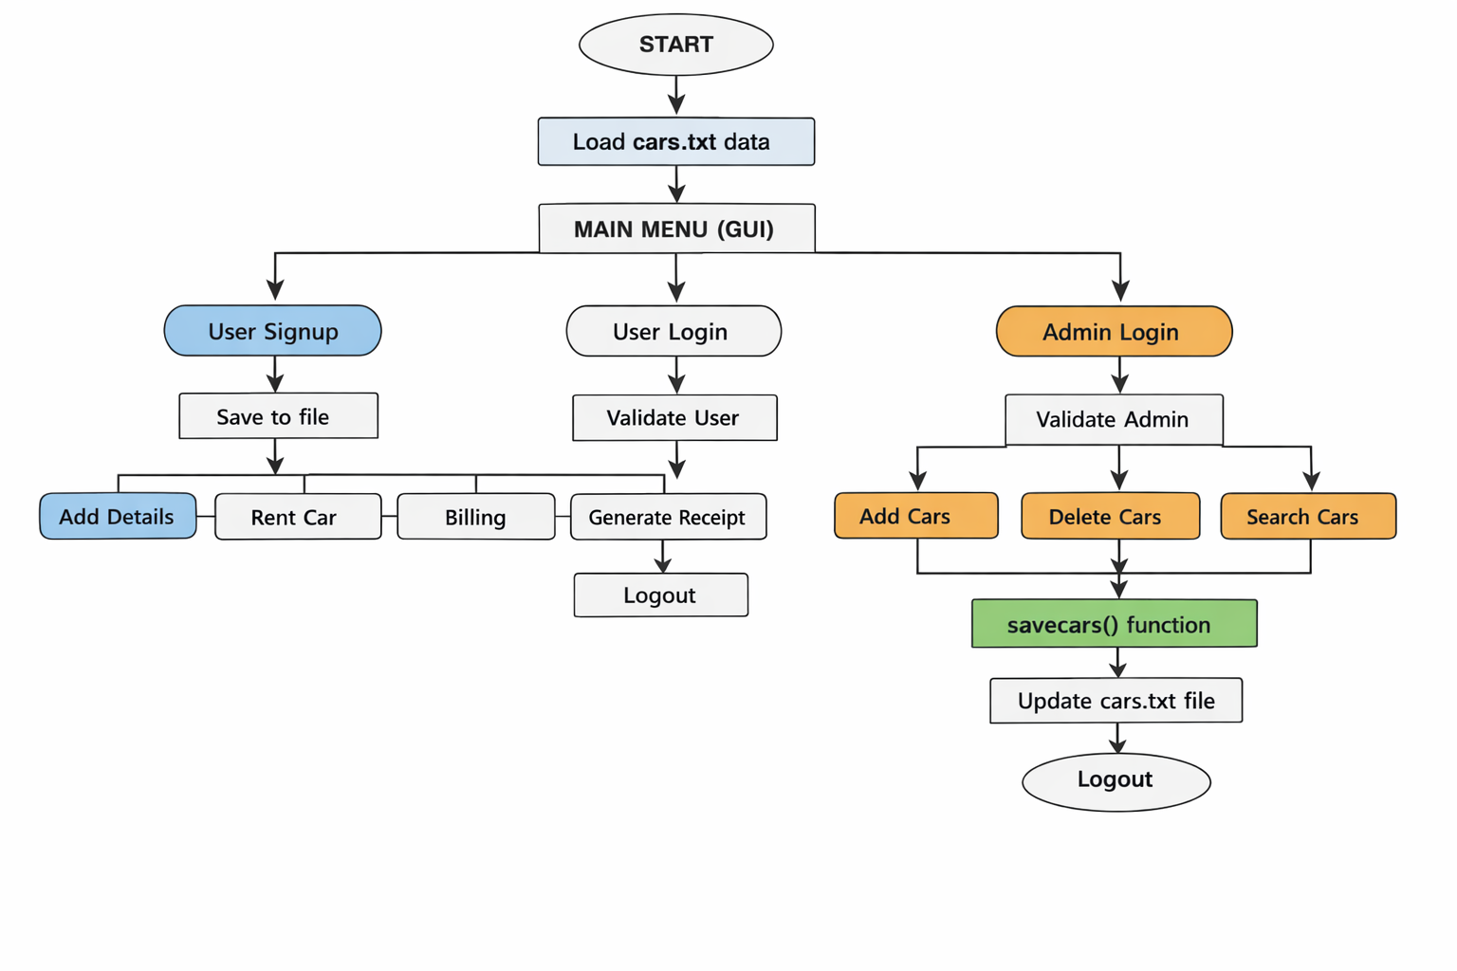

- Weakness in the Business Application
- Fixed Data Size: The application uses static arrays (MAX_CARS = 100), which limits the scalability of the business. It cannot handle more than 100 users or cars without recompiling the code.
- Data Security: Passwords and user data are stored in plain text files (users.txt, cars.txt) without encryption, making the system vulnerable to unauthorized access.
- No Input Sanitization: While there are basic checks, the system is still prone to errors if a user enters a string when an integer is expected (e.g., in menu choices), which can cause the program to crash or loop infinitely.
- Single Session Limitations: The billing variables (like currentCustName) are global and overwritten easily. If the program closes, the current active rental session is lost before the receipt is printed if not saved to a specific transaction file.

- Future Directions
- Object-Oriented Programming (OOP): In the next semester, I plan to refactor the code to use Classes and Objects. This will better organize the data (grouping car details into a Car object) and improve code reusability.
- Dynamic Memory Allocation: Instead of fixed arrays, I will use Vectors or dynamic pointers to allow the system to handle an unlimited number of customers and cars.
- Graphical User Interface (GUI): Moving away from the console (black screen) to a visual interface with buttons and forms to make it more user-friendly for non-technical staff.

